**Update Patient Post Codes**

**Description:**

This code enumerates over every patient in the database,(The Where clause has been commented).

It finds the equivalent patient in the PAS **LPIPatientData** and replaces the postcode in the **Patients** table.

It then does a call to **SetDistanceFromWythenshawe** and writes that to table **Patients**.

Views\Imports\**_Distance.cshtml** is a partial form part of tabbed formViews\Imports\**New.cshtml**

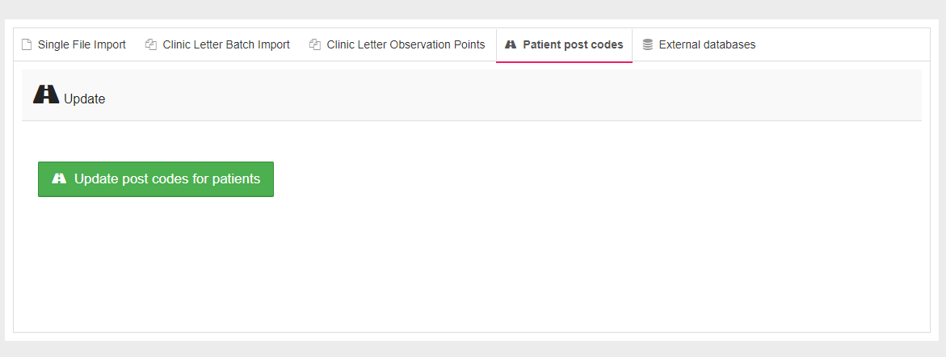

***<div class="col-12" style="margin: 0 auto; padding-top:50px; padding-left: 20px">***

***<button class="btn btn-lg btn-success" id="distance-update">***

***<i class="fa fa-road"></i>&nbsp; Update post codes for patients***

***</button>***

***</div>***

Button click event set in **Patient.js**

***var distanceUpdate = function () {***

***$(document).off("click.distance").on("click.distance", "button#distance-update", function (e) {***

***e.preventDefault();***

***LoadingIndicator.show();***

***$.post("/postcodes/update", function (response) {***

***LoadingIndicator.hide();***

***});***

***});***

***};***

Calls **Update** action Method on Controllers\**PostcodesController.cs**

**Note:**

Removing the Where clause makes this a long running process (5 hours), but does update postcodes for anyone who may have moved.

*[HttpPost]*

***public IActionResult Update()***

***{***

***var patientsWithoutPostCodes = _context.Patients; //.Where(p => p.PostCode == null);***

***foreach(var patientWithoutPostCode in patientsWithoutPostCodes)***

***{***

***var lpiPatientData = _pasDbContext.LpiPatientData.FirstOrDefault(p => p.DistrictNumber() == patientWithoutPostCode.DistrictNumber);***

***if (lpiPatientData == null || lpiPatientData.POSTCODE == null) continue;***

***patientWithoutPostCode.PostCode = lpiPatientData.POSTCODE;***

***patientWithoutPostCode.SetDistanceFromWythenshawe(_context, _logger);***

***_context.Update(patientWithoutPostCode);***

***}***

***_context.SaveChanges();***

***return RedirectToAction("New", "Imports");***

***}***

**SetDistanceFromWythenshawe** is a property on Models\**Patient.cs**, it relies on **GraphHopper** running to calculate the distance.

***public void SetDistanceFromWythenshawe(AspergillosisContext context, ILogger logger)***

***{***

***var patientPosition = PatientPosition(context);***

***var distanceCalculator = new GraphhopperApi(new RestClient(GraphhopperApi.ENDPOINT), logger);***

***var distance = distanceCalculator.RequestDistance(patientPosition);***

***DistanceFromWythenshawe = (double) distance;***

***}***